Field Trip Name:
Date of Risk Assessment:
List any attachments or referenced documents that are relevant to this risk assessment:
Describe Field Trip Objective/s:
(Detail if not recorded elsewhere)
Name of Field Trip Risk Approver:
(Detail if not recorded elsewhere)
Name of Field Trip Leader:
(Detail if not recorded elsewhere)
Additional people involved in risk assessment process:
(Detail if not recorded elsewhere)

Procedure for completing your | risk assessment
- Identify risk factor/hazard | The risk factor/hazard is the source of harm, e.g. equipment. Use Identify your Risks (Issues for Consideration) to assist you.
- Describe your risk | The risk is what could happen as a result of the hazard, e.g. back strain from lifting equipment.
- Assessed risk | Existing controls – what do you currently have in place to lessen the level of risk.  Use the risk matrix to assess the level of risk, considering these existing controls.
- Risk Control measure | What further control measures will you put in place to minimise the risk. Think of both short term (can fix immediately) and long term control (controls that may need additional resources to be allocated) measures.  Assign a person responsible to implement these controls and a due date for their completion.  Given these further control measures what will be the new risk rating. Use the risk matrix to re-assess the level.

The Hierarchy of Control
Eliminate the risk, or if this not reasonably practicable, control the risk to the fullest extent possible by using the following hierarchy of controls:
- Elimination – remove the hazard. Change the activity or stop using it, e.g. do not travel to a Department of Foreign Affairs and Trade (DFAT) 4 country.
- Substitution – replace the activity, material or equipment with a less hazard one, e.g. substitute a manual task for an automated task.
- Isolation – isolate the hazard from the person at risk, e.g. separate pedestrian access from vehicular access.
- Engineering – Use guarding on equipment in workshops.
- Administrative Controls – Training, Standard Operating Procedures and completing a Risk Assessment.
- Personal Protective Equipment (PPE) – Use appropriate and proper fitting equipment, e.g. safety goggles, gloves and lab coats. PPE is to be used in conjunction with other control measures.

Practicable – Consider
When completing a risk assessment the following must be considered in the priority of order of Number 1 – 4:
- Severity of hazard or risk;
- Knowledge of hazard or risk and ways of removing it;
- Availability and suitability of ways to remove or mitigate risk;
- Cost of removing or mitigating hazard or risk.

Risk Matrix
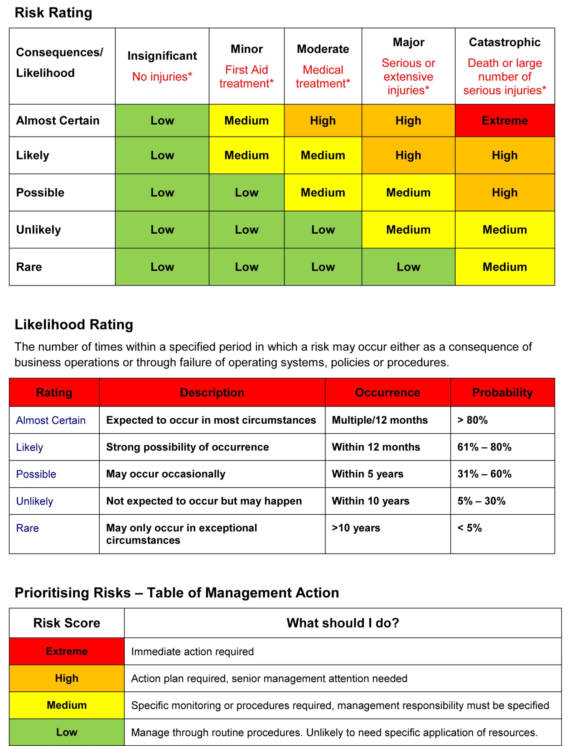

Identify your Risks
IDENTIFY |  | ASSESS |  |  | CONTROL
Risk Factor/ Hazard | Describe your risk | What are your existing controls? | Current risk rating? | To further reduce risk what proposed controls have you considered? | Who is responsible for these controls? | Due date | Residual risk rating?
Manual Tasks | Manual Handling Consider injuries arising from use of force exerted by a person to lift, lower, push, pull, carry or otherwise move, hold or restrain a person, animal or thing.  E.G. Lifting equipment in/out of field vehicle. Carrying equipment in the field. | Sample controls – add/delete for specific field trip, as appropriate  - Provision of Manual Handling training (online Manual Handling training module)  - Manual handling minimised, where possible.  - Correct manual handling techniques applied, including using more than one person to lift/carry item/s, where necessary.  - Lifting/carrying aids used,  - Personal Protective clothing worn, where appropriate.
Manual Tasks | Musculoskeletal Injury arising from slips, trips and falls  E.g. slip/fall while traversing slippery/ uneven terrain. | - Appropriate clothing and footwear worn.  - Training/induction in and application of good ergonomic techniques.  - Extra care taken when working in slippery/muddy/wet conditions.  - Ensure clear vision and watch where walking.  - Appropriate time management practices to ensure adequate time for transit/travel and field activities purposes.
Biological | Hazardous Organisms  Injury or illness due to allergic reaction, bites, envenomation, inhalation and infection from contact with organisms in the field.  E.G. mosquito bites resulting in infection/ disease (dengue fever, yellow fever, malaria) | - Allergy sufferers identified prior to trip and appropriate control implemented.  - Repelling devices or substances available and used as necessary  - Provision of animal handling or avoidance training.  - Buddy system.  - Appropriate immunisation/ vaccination.  - PPE provided and used, where appropriate (sturdy footwear and thick pants)  - All personnel aware of closest emergency medical facilities (hospital, doctor’s surgery etc.)  - Access to communication devices, suitable for specific field locations  - First aid resources (Kit, First Aid Officer, Medical facilities) available.
Physical | Exposure to Physical environment  Injury or illness resulting from dehydration, fatigue, sunburn, and heat exhaustion, exposure to extreme weather events (storms, floods, fires)  E.G. Hyperthermia from working outdoors in peak sun/heat exposure times collecting samples. | - Access to drinking water at all times.  - Access to food.  - Good food storage and hygiene practices in place.  - Regular rest breaks incorporated into daily activities.  - Personal Protective clothing worn, where appropriate  - Wearing of sunscreen and re-application regularly.  - Work activities and workloads monitored and reviewed as necessary.  - Ongoing monitoring of environmental conditions (e.g. changing weather conditions) and modifications of activities and or locations as necessary.  - Avoid extreme environmental conditions where possible.  - Allow time for acclimatisation.  - Travel plans registered with ISOS.
People | Transportation of People  Injury or illness resulting from land, sea and air transport incident or event.  E.G. movement of unsecured field equipment in vehicle causing injury to occupant/s during off-road travel. | - Travel booked through Griffith University preferred supplier, where possible.  - Use of appropriately registered and maintained vehicles and craft.  - When using public transport options, only reputable and registered service providers’ services used.  - Adherence to service providers’ safety policies and procedures whilst using their services.  - Service provider contact details noted/ attached to Field Trip Operational Plan.  - Trip planned with adequate replenishment and rest periods (person and vehicle).  - Adherence to University Travel Policy.  - Adherence to ‘Guide to Driving on University Business’.  - Driver/s hold appropriate current licence/s.  - Driver/s have undertaken 4WD training course, where appropriate.  - Adherence to ‘Griffith University Boating Safety Guidelines and Procedures Manual’.  - Communication devices suitable and useable in transit and destination locations.  - Destination country travel warnings and health risks reviewed prior to commencement, and monitored for duration of field trip.  - Itinerary details noted/attached to Field Trip Operational Plan.  - Travel Doctor consulted re necessary vaccinations and medications.  - Travel registered with ISOS.  - Travel registered with SmartTravel.gov.au.
People | Risk of injury as a result of an physical incident (violence, cultural or social conflict, personal assault).  e.g. Whilst in an overseas country, personal items (including cash, passport) were taken. | - Review destination country travel warnings  - Limiting the amount of cash taken  - Have copies of passports with another person  - Ensure that observation of local customs are known and observed.  - Working with others and that emergency numbers and plans are known.
Energy | Electrical  Injury or death from exposure to hazardous electrical voltage and amperage, including from damaged, faulty or poorly designed electrical equipment or equipment used in unsuitable/hostile field conditions (wet environment, unstable power supply, etc.)  e.g. Untested equipment which is potentially unsafe and may cause electric shock. | - Provision of activity-specific training.  - Equipment in good condition and suitable for conditions of use.  - University electrical equipment tested and tagged.  - Repair and maintenance procedures in place and adhered to.  - Prohibition of double adaptors or piggyback plugs.  - Tag out procedure for faulty or damaged equipment.

Continue adding further identified hazards/risks here:
IDENTIFY |  | ASSESS |  |  | CONTROL
Risk Factor/ Hazard | Describe your risk | What are your existing controls? | Current risk rating? | To further reduce risk what proposed controls have you considered? | Who is responsible for these controls? | Due date | Residual risk rating?

Approved by (Name): ________________________

Signature (email address when completing this form on-line is acceptable): ___________________________

Date: ____________

Further Information for Consideration
- Review information from manufacturers or operators of plant and equipment.
- Review information from health and safety journals, hazard alerts, incident reports, first aid register, workers’ compensation records, maintenance records or SDSs.
- Codes of Practice and Legislation.
- Access Australian and International Standards via the Griffith University licence.

Review How to Manage Work Health and Safety Risks Code of Practice 2011 and AS 1470-1986 Health and Safety at Work – Principles and practices.

Risk Factor | Hazard Description | Consider | Legislation/Codes of Practice that may assist you
Biological | Animal tissue/fluids  Biological Material | Environmental Exposure  Health Effects and Exposure Routes | AS 1894-1997 The storage and handling of non-flammable cryogenic and refrigerated liquids
 | Human tissue/fluids | Level of Physical Containment Facilities | AS 2182-1998 Sterilizers – Steam - Benchtop
 | Irritants | Storage and Handling | AS 2243 Safety in laboratories
 | Plant Material | Transport and Disposal | AS 2252 Biological safety cabinets
 | Any other biological hazards? |  | AS 3745-2010 Planning for emergencies in facilities
 |  |  | AS 4775-2007 Emergency eyewash and shower equipment
Chemical | Chemicals (attach current SDS) | Duration of Exposure | Labelling of workplace hazardous chemicals COP 2011
 | Dangerous Goods  Drugs (attach current SDS) | Health Effects and Exposure routes Labelling | Managing risks of hazardous chemicals in the workplace COP 2013
 | Hazardous Substances (attach current SDS) | Reactivity | National COP for Chemicals of Security Concerns
 | Nanoparticles  Poisons (attach current SDS) | Storage and Handling  Transport and Disposal | AS 1940-2004 The storage and handling of flammable and combustible liquids
 | Any other hazardous materials hazards? |  | AS 2243 Safety in laboratories
 |  |  | AS 2830.1-1985 Good laboratory practice – Chemical analysis
 |  |  | AS 3745-2010 Planning for emergencies in facilities
 |  |  | AS3780-2008 The storage and handling of corrosive substances
 |  |  | AS 4775-2007 Emergency eyewash and shower equipment
Energy | Electrical | Equipment | Managing Noise & Preventing Hearing Loss at Work COP 2011
 | Laser | Experience | AS 2243 Safety in laboratories
 | Noise | Exposure Routes | AS/NZS 1269 Occupational noise management
 | Radiation  Vibration | Hazardous Materials | ISO 2919:2012 Radiological protection – Sealed radioactive sources – General requirements and classification
 | Any other energy hazards? |  | ISO 3925:1978 Unsealed radioactive substances – Identification and certification
Manual Tasks | Force | Environment | Hazardous Manual Tasks COP 2011
 | Nature of Load | Pushing/pulling | Manual tasks involving the handling of people COP 2001
 | Posture | Sustained, repetitive action
 | Repetition
 | Any other manual task hazards?
People | Psycho-social | Expectations | Prevention of Workplace Harassment COP 2004
 | Travelling/journey | Manual Tasks
 | Working alone/late | Personal Issues
 | Working from home | Physical
 | Any other people hazards? | Plant and Equipment
 |  | Security
Physical | Confined/enclosed spaces | Communication | Confined Space COP 2011
 | Construction work | Environment including Weather | Managing the Risks of Falls at Workplaces COP 2011
 | Environmental conditions | Equipment | Managing the Work Environment and Facilities COP 2011
 | Evacuation  Field work | Experience  Hazardous Materials | Recreational Diving, Recreational Technical Diving and Snorkelling COP 2011
 | First Aid | Location | AS 2865-2009 Confined spaces
 | Slip, trip, fall  Work area design | Medical Factors  Transport | AS/NZS 2299 Occupational diving operations – Standard operational practice
 | Working at heights
 | Any other physical hazards?
Plant | Crushing | Guarding | Managing Noise & Preventing Hearing Loss at Work COP 2011
 | Cutting, stabbing and puncturing | Noise | Managing Risks of Plant in the Workplace COP 2013
 | Entanglement | Training | AS 1473-1991 Guarding and safe use of woodworking machinery
 | Equipment/tools – powered/non-powered Ergonomics | Type  Working Alone | AS 1893-1977 Code of practice for the guarding and safe use of metal and paper cutting guillotines
 | Explosion |  | AS 4024 Safety of machinery
 | Friction  High pressure fluid |  | AS 4839-2001 The safe use of portable and mobile oxy-fuel gas systems for welding, cutting, heating & allied processes
 | Impact |  | AS/NZS 1269 Occupational noise management
 | Suffocation
 | Temperature extremes
 | Any other plant hazards?
Travel | Unfamiliar with local customs  Travelling alone/safe travel  Medical conditions  Climate  Hostile environment (e.g. desert, snow, jungle)  Contact with animals (domestic, wild, feral)  Insects  Safe drinking water  Safe food  Accommodation  Local sanitation  Language barrier  Obtaining emergency services and adequate medical care  Safety standards  Confined spaces  Working with or exposure to hazardous chemicals  Working with potentially hazardous equipment  Communication | Register with smarttraveller.gov.au  Travel fact sheets  Travel insurance  Travel assistance - ISOS

