Gender Equality Research Network

Research Seed Support Scheme

Outcome Report

Please submit completed report by 23 December 2022.

Please send to a.macdonald@griffith.edu.au

PROJECT DETAILS

Grant Research Title: Understanding Refugee’s Oral Health Services in Queensland

Name of Project CI: Professor Juliet Pietsch

Project Team Members: Connie Gan, Phyu Phyu Oo, Thu Nguyen, Christina Green

External: Dr Alice Lu, Donata Sackey

SUMMARY OF RESEARCH CONDUCTED

- A literature review on refugee health needs and gender
- An evaluation of operational records of Tzu Chi dental fair for new refugees between 2004 to 2019 was undertaken.
- Feasibility analysis on a one-stop dental fair program on addressing barriers/factors associated with access to dental care among refugees.
- Interviewed clinical and non-clinical volunteers
- We compiled relevant policy documents, organisation information,
- A review on the existing dental care services to exclusive to serve the newly arrived refugee.

Remainder of the fund: Will be used for Transcription and developing report design.

PLEASE EXPLAIN HOW YOUR PROJECT PROMOTED MULTI-DISCIPLINARY RESEARCH AND COLLABORATION WITHIN THE NETWORK ON GENDER

The research focuses on availability and accessibility of oral health and dental care services for Refugees in Queensland. Tzu Chi foundation provide dental care services to Refugees in Queensland who have no or very limited access to formal government services. The research studies and analyse the existing state government policies for accessing oral health in Queensland for Refugees. The research then analyses the role of Tzu Chi foundation and the gender sensitiveness of the services they provide.

Quantitative analysis provides age and sex aggregated data that informs the needs of and access to oral health services among different sex categories among Refugees in Queensland. The analysis also informs the improvements in collecting sex and age aggerated data.

Qualitative data, on the other hand, collects information on the delivery of services and perspectives of service providers on Refugee’s access to oral health care. The scope of data collection captures gender sensitiveness or gender sensitive awareness of health care worker and support staff while delivering services. The outcomes of the qualitative analysis inform the gender responsiveness of the service delivery and recommendations for improvement.

Preliminary findings:
Predisposing factors, such as English language proficiency, education, health and dental literacy and acculturation and integration, were shown to be significantly associated with refugees' access to dental care. However, there is limited evidence to determine the effect of individual enabling and need and contextual factors especially in a gender-sensitive lens.

LIST THE OUTCOMES FROM THE PROJECT: RESEARCH (ie PUBLICATION, GRANT APPLICATIONS, AND/OR ENGAGEMENT (EXTERNAL IMPACT)

- Engagement with industry partners: Tzu Chi Foundation and Refugee Health Network Queensland
- Submitted (and received approval) for an ethical clearance application relating to interview guide and delivery (GU ref no: 2022/081)
- A dashboard to visualise dental fair data for stakeholders to gain insights into areas that need improvement as well as track performance (Annex 1). This visual information tool has helped spot trends over time and facilitate discussion on the data management for the upcoming dental fair in Toowoomba.
- Discussion with stakeholders on the implementation of QLD’s Refugee Health and Wellbeing Policy and Action Plan 2022-2027 especially on ways to “support on going research to develop innovative models of care for people from refugee background”.
- Draft manuscript entitled: “Dental Health Care for Post-Arrival Refugee Community in Queensland” to be submitted to journal: Community Dentistry and Oral Epidemiology.

HOW DID THIS PROJECT PROMOTE RESEARCH COLLABORATION WITHIN THE NETWORK, INCLUDING ACROSS ALL ACADEMIC

Collaboration between SGIR and School of Medicine and Dentistry (SoMAD)
Two post-graduate student projects including one 12-week Summer Research Program $1,800 scholarship.
Two Master of Public Health (Dissertation). (1) Enhancing Dental Health Literacy and Self-Efficacy in New Settlers: The Role of Dental Practitioners; (2) Oral health service utilization of migrants: implications for public health policy.

RECOMMENDATIONS FOR FUTURE DEVELOPMENT / NEXT STEPS

- Dissemination result/report plan to Queensland Refugee Health Network, Tzu Chi Foundation, Queensland Ethnic Community Council,
- Refine data collection methods and pilot in the next dental fair
- Identify synergies with other research project: Connie’s Queensland Resilience and Risk Reduction Fund “Fostering Culturally Inclusive Emergency Management”.

PLEASE PROVIDE A BUDGET SHOWING HOW THIS GRANT WAS EXPENDED

EXPENDITURE ITEM: | AMOUNT EXPENDED
Personnel
Travel
Running expenses
Other
TOTAL

Have all claims been expended against this account so that it can be closed?

Yes No

Annex 1: Snapshot of dashboard of Tzu Chi Dental

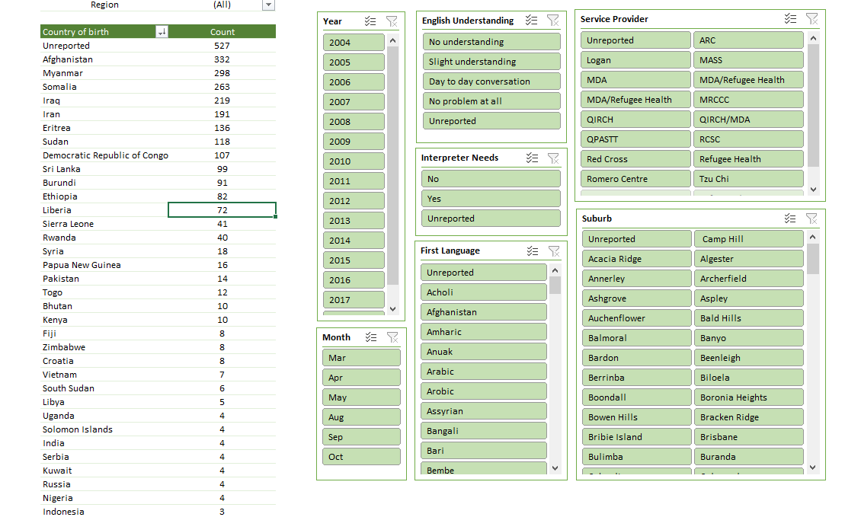
Annex 2: Descriptive statistic

- Sex assigned at birth

- Total of n=2810 received treatment in (n=?) dental fairs between 2004 to 2019
- Just over 15% have no sex data recorded in the dataset
- male (44%) is slightly more than female (40%)
- trends / ratio changes across age groups, fewer male in the age above 70
- trends and ratio changes throughout the years?

- Age at treatment

- The graph showed unimodal with a mode of 20-24 and age distribution is slightly left skewed.
- Similar trends for both male and female

- English understanding

