Mandatory Facility Entry Requirements
IN CASE OF EMERGENCY DIAL 000
<Managing Element>
<Building>
<Room Number>
<Facility Containment Level>
<Cleaning Scope>


ACCESS RISK LEVEL: <NO NOTIFICATION/NOTIFICATION/SUPERVISION>
Contractors MUST be inducted before entering this area

Griffith Directory

FACILITY CONTACTS:
<position> | <name> | <office location> | <contact number>
<position> | <name> | <office location> | <contact number>
<position> | <name> | <office location> | <contact number>
<position> | <name> | <office location> | <contact number>
AFTER-HOURS CONTACT:
<position> | <name> | <office location> | <contact number>
FACILITY REQUIREMENTS AND PPE:

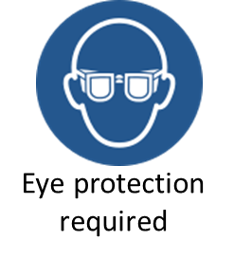
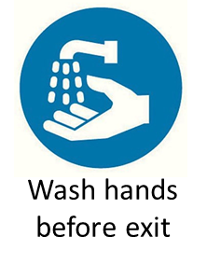
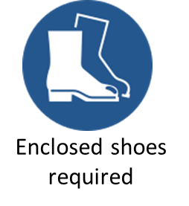
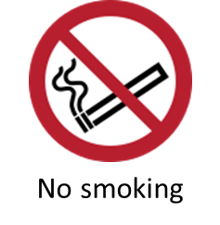


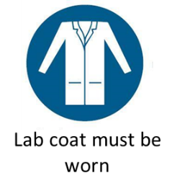

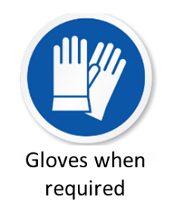


HAZARDS:

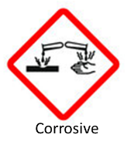
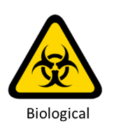
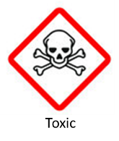
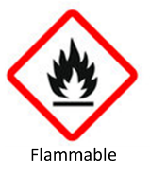
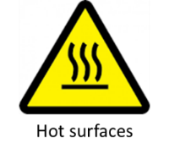
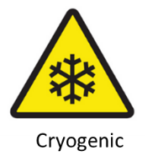
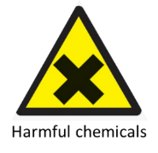


Chemwatch

How to use this template

- This sign does not replace regulatory signage (PC2 work practices, OGTR certification, Biosecurity signage).
- Items in brackets are to be completed specifically for the facility intended.
- Facility containment level (colour coded); No containment level (i.e. clinical spaces, teaching facilities; non-coloured), PC1, BC5.1, PC2, BC5.2.
- Cleaning scope (colour coded); daily clean, weekly clean, do not clean, research laboratory, teaching laboratory.
- Access level for visitors/contractors:
- Unrestricted - No notification required for access.
- Restricted – Notification required for access.
- Highly restricted – Notification AND supervision required for access.
- The sign is intended for printing at A3 size and in colour. Please laminate prior to erecting on the facility door.
- Please ensure an appropriate review period is implemented to ensure signage remains current.
- The emergency contacts can be manually written on top of the lamination to allow for cleaning and replacement when necessary, without reprinting.
- Available pictograms for PPE and hazards are below. Please select or remove as necessary for the facility. This list is not exhaustive, please send anything you would like included.
- Any feedback/suggestions or assistance regarding the sign template are to be directed to jamie.mills@griffith.edu.au.

FACILITY REQUIREMENTS AND PPE:
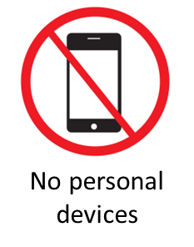
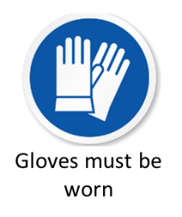
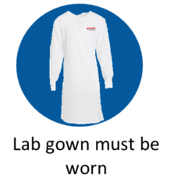

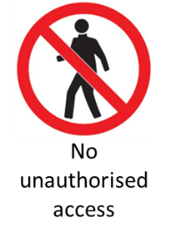
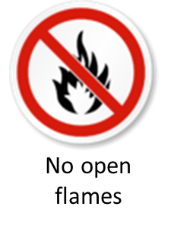
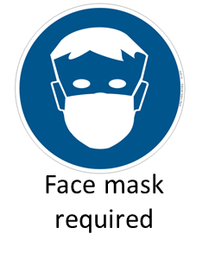

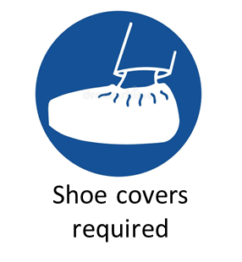
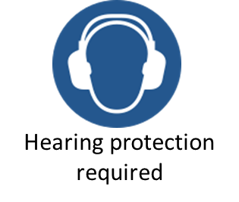


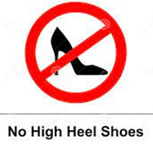


FACILITY HAZARDS:
