Chemical Waste Labelling
- Purpose
This document outlines the requirements for the labelling of laboratory and other chemical waste to manage chemical incompatibility, or risk to people or the environment during collection, storage and transportation prior to disposal.
- Scope
This procedure applies to all staff, students, volunteers and visitors that store, use, generate or handle laboratory and other chemical waste while undertaking activities at or for the University.
- Scope Exclusions
The following waste materials require specific procedures and must not be transferred to waste collection locations.
- Asbestos and asbestos containing materials (ACM).
- Goods too dangerous to be transported.
- Pyrophoric liquids and solids.
- Definitions and Terms
Dangerous Goods are substances, mixtures or articles that, because of their physical, chemical (physicochemical) or acute toxicity properties, present an immediate hazard to people, property or the environment. They are assigned to specific classes in accordance with the Australian Code for the Transport of Dangerous Goods by Road & Rail, (ADG) Code.
- Procedure
Prior to the collection and disposal of chemical waste by a commercial licensed chemical waste company, workplaces are responsible for correctly labelling and storing unwanted chemicals and the chemical waste they have produced. Please refer to Hazardous waste disposal guidelines which outlines methods of chemical waste disposal.
- Containers for Chemical Waste
Depending on the chemical’s physical properties and volume you can use any of the following disposal containers:
- dangerous goods grade plastic drum (available from the “Gold Coast and Nathan Science stores”);
- glass or plastic winchester bottles; and/or
- the original container as supplied by the manufacturer.
- Labelling Chemical Waste
All chemical waste containers must be labelled with applicable Australian Dangerous Goods Code (ADG) labelling. ADG code labelling ensures that the waste can be easily segregated in storage prior to collection and so that the commercial chemical waste contractor knows exactly what is collected for transport and eventual disposal. Please refer to the Chemical waste template and example provided as figures 1 & 2.

A Chemical Waste Label must contain the following detail:
- The FULL NAME of the waste. Abbreviations and symbols are not to be used.
- List the chemicals and solvents and their concentrations.
- Enter the applicable hazard and precautionary statements applicable to the mixture.
- Contact details must be filled out.
- Relevant ADG Class/division labels (Dangerous Goods diamonds) must be displayed in the appropriate space. Contact CRS (CRS@griffith.edu.au) for more information.
- REFERENCES
- AS/NZS 2243.2:2021- Safety in Laboratories, Part 2: Chemical aspects and storage
- Australian Code for the Transport of Dangerous Goods by Road & Rail Ed 7.9 (National Transport Commission, Melbourne).
- ‘Hazardous waste disposal guidelines’ (Health Safety and Wellbeing, Griffith University).

{SIGNAL WORD} | HAZARDOUS CHEMICAL WASTE |  | ITEM: {1/2}
{WASTE NAME}  Contains:  Chlorinated: {YES / NO} |  | HAZARD STATEMENTS:  {Enter statements applicable to the mixture}  PRECAUTIONARY STATEMENTS:  {Enter statements applicable to the mixture}  Keep container tightly closed  Call a POISONS CENTRE or doctor/physician if feeling unwell.
{Lab/Group name} Date: {dd/mm/yy}
Contact: {Initial / Name} Phone: x {nnnnn}
{ } Campus
Building: {Number} Room: {Number}
Refer to Safety Data Sheets for further information.
Refer to Hazardous waste disposal guidelines for authorised disposal procedures or contact Chemicals & Radiation Safety, (07) 373 58880
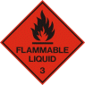
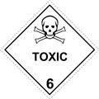
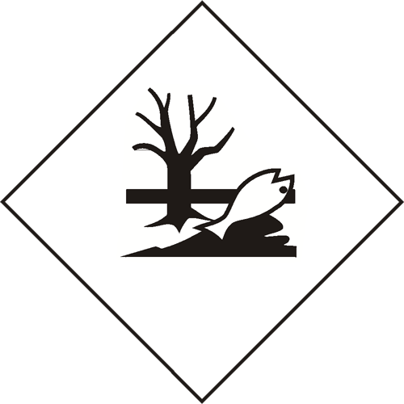
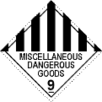
DG symbol(s): {retain the applicable PRIMARY class only}

Figure 1 - Chemical Waste Label TEMPLATE

DANGER | HAZARDOUS CHEMICAL WASTE |  | ITEM: 1/1
Organic Solvent Waste  Contains:  Ethanol: 60%  Xylene: 20%  Methanol: 10%  Water: 10%  Chlorinated: NO  Figure 2 - Chemical Waste Label EXAMPLE |  | HAZARD STATEMENTS:  H225 - Highly flammable liquid and vapour.  H302 - Harmful if swallowed.  H312 - Harmful in contact with skin.  H315 - Causes skin irritation.  H319 - Causes serious eye irritation.  H332 - Harmful if inhaled.  H336 - May cause drowsiness or dizziness.  H3600D - May damage the unborn child.  H370 - Causes damage to organs.  H373 - May cause damage to organs through prolonged or repeated exposure.  PRECAUTIONARY STATEMENTS:  Store in cool, dry, protected area.  Keep container in a well-ventilated place.  Keep away from sources of ignition. No smoking.
DG symbol(s):

Technical Services Date: 28-August-2025
Contact: Svante Arrhenius Phone: x246XX
Building: G0X Lab: X.XX
Gold Coast Campus

Refer to Hazardous waste disposal guidelines for authorised disposal procedures or contact Chemicals & Radiation Safety, (07) 373 58880
Figure 2 - Chemical Waste Label EXAMPLE

