How to Register the HSK/HSKK/YCT test online

- Please open the Chinese test website: http://www.chinesetest.cn/ChangeLan.do?languge=en&t=1620712351715
- Click Test Taker and then click New User.
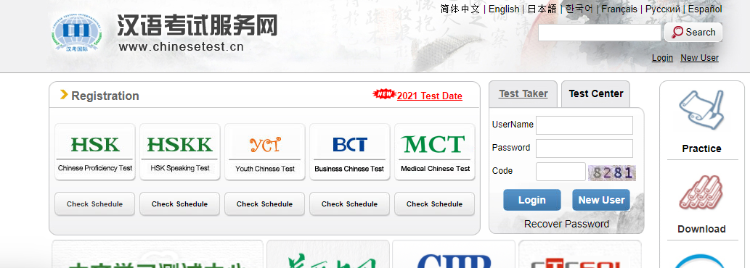

- Fill in the information to open an Account as follows:
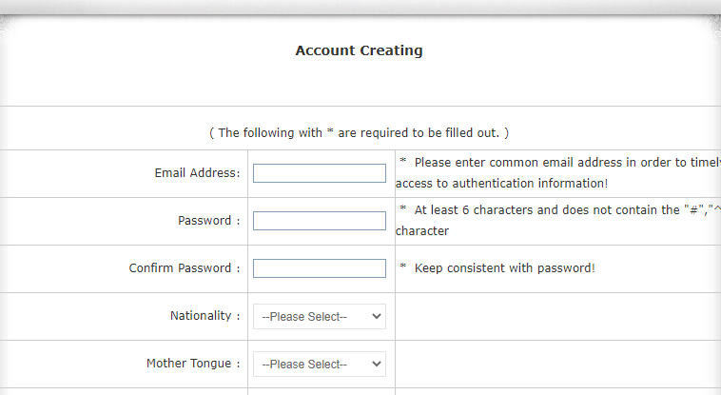

- Enter Register now and complete the step-by-step questions.
- Please be noted that the only available form of test is paper-based test in our test centre, about for Test Centre options, choose Tourism Confucius Institute at Griffith University and the fixed test date.
- Before uploading the photo, make sure you have a JPG photo of less than 100 K with the pixel size of 180 pixels * 240 pixels.
- Double check all the information before the confirmation.
- Please send an email to tci@griffith.edu.au for a registration notice.

