Deconstructing the Assignment Question – Organising your Notes

Sample Essay Question
“Discuss the advances in the Australian healthcare system over the last 20 years, including an examination of changes in technology, access to healthcare facilities, the impact of private health insurance and the increase of urbanisation.”

Main Topic – what is the task about?
Limits or Boundaries – what is the scope of the task?
Directive Words – what specifically are you being asked to do?

Once you have deconstructed your question and know exactly what you need to address, you can begin to make a rough plan to help you keep your notes organised.

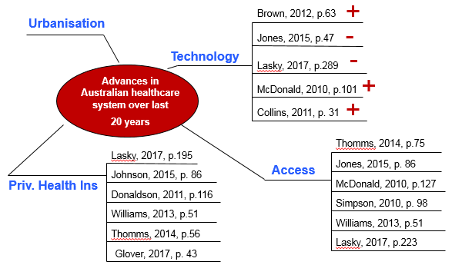
You might draw a MIND MAP like this

Or perhaps you prefer to rule up a TABLE
Article | Subtopic | Key argument | Important points | Comments
Jones, 2010 | Access to healthcare facilities | Remote areas have difficulty attracting qualified medical practitioners | See p 10 for example of West Qld  Also NT islands | Indigenous health and those in very remote locations suffer  Higher % of mortality due to lack of facilities (p. 12 stats)

Or write each SUBTOPIC AS HEADING ON A NEW PAGE
Advances in Technology
Jones, 2010 p10

Private Health Insurance
Taylor & Crisp 2016 p246
($$ since 2010)

Access to healthcare facilities
Smith, 2014 p102
(Indigenous)
Phillips, 2017 p35
(West Qld, farmers example)

Increase in Urbanisation
Rogers, 2011 p12 (% growth of Australian cities since 1980)

