Creating an Activity Application
Step 1: Log into GSafe
You can log into GSafe from the Health, Safety & Wellbeing page https://www.griffith.edu.au/health-safety-wellbeing by selecting the link at the ‘Access GSafe desktop edition >’ button.
Figure 1

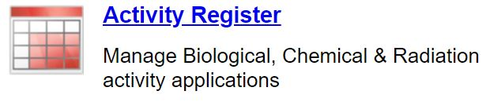
Step 2: Access the Activity Register
Figure 2
Open the activity register by selecting the underlined text (Activity Register) adjacent to the icon (Figure 2). The Activity Register will open with the list of the existing Activities in the Register.

Step 3: Start a New Application
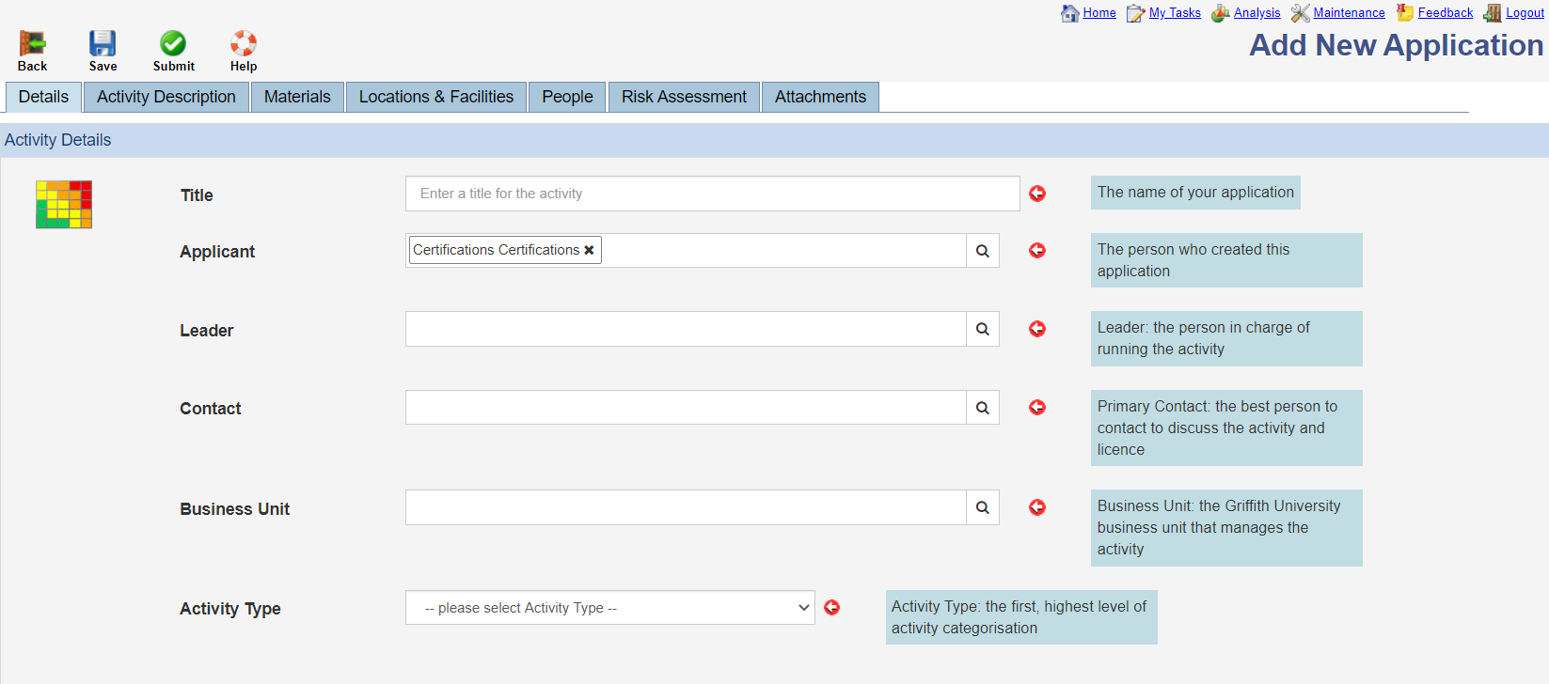
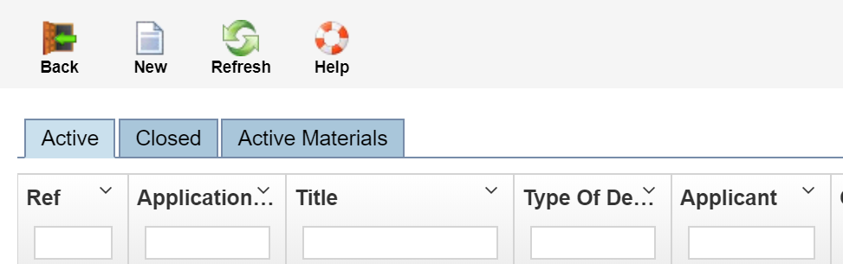
To start an application, enter the Lab Activity Register and press the ‘New’ icon in the Toolbar above the Register (Figure 3). The Add New Application window will appear (Figure 4) containing seven tabs. Each tab contains fields that require filling with information about the activity. Start on the Details Tab and complete all fields - your name will be prefilled in the ‘Applicant’ field. Brief descriptions for each field are included for each field and mandatory fields are marked with a red arrow.
Figure 4
Mandatory Fields
Figure 3

Step 4: Completing the remainder of the Application
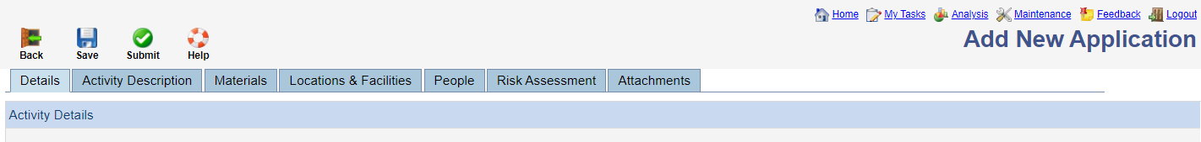
Complete the remainder of the application by moving through the tabs and completing required information for your proposed activity.
Figure 5

The table below provides additional information about what to include within each of the tabs.
Details Add basic application details - status, reference, title, applicants, type etc. The New Application will start on this tab and fields here are completed first. This is where the Activity Type, Activity Category and Dealing Type is selected.
Activity Description Give an overview of the project aims in the Project Description field. Include specific detailed information within the Project Details section in the Experimental Procedures field. GMO Classification (where applicable) must be selected for GMO Dealings applications and where required include Storage and Disposal procedures, Safety and Risk Management precautions.
Materials Include the materials to be used in the activity. Click the ‘Display Materials’ button to load the materials already listed then select the + to ‘Add Material’ or the 🖉 to open and edit an existing material. Material Type is selected when adding a material and it is important to select the correct material type for Regulated Materials such as GMOs. Include the other required fields (common and scientific names) and continue filling in fields with information that you have available on the material. Including more information will assist the review of your application.
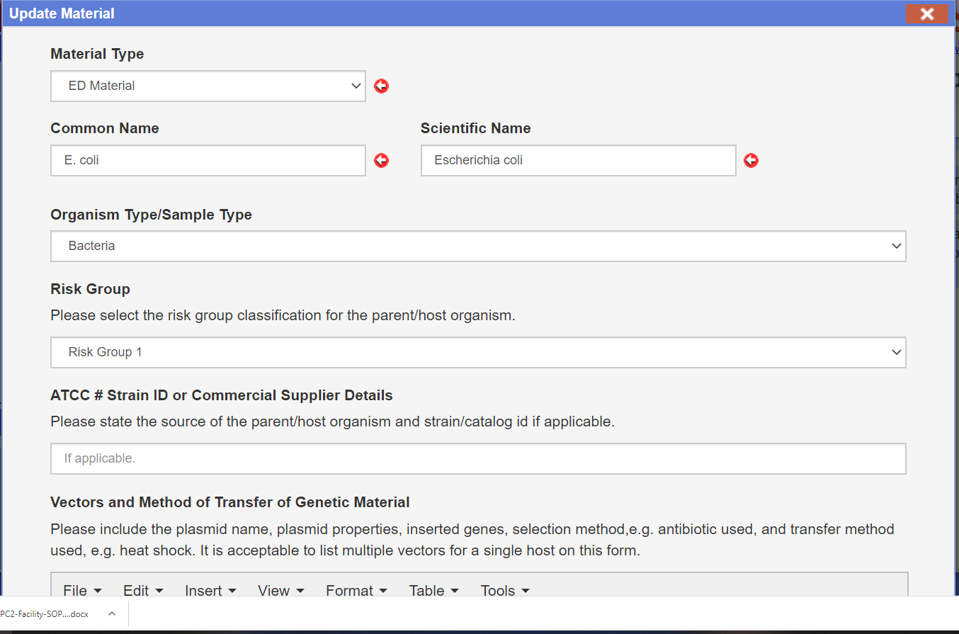
Figure 6

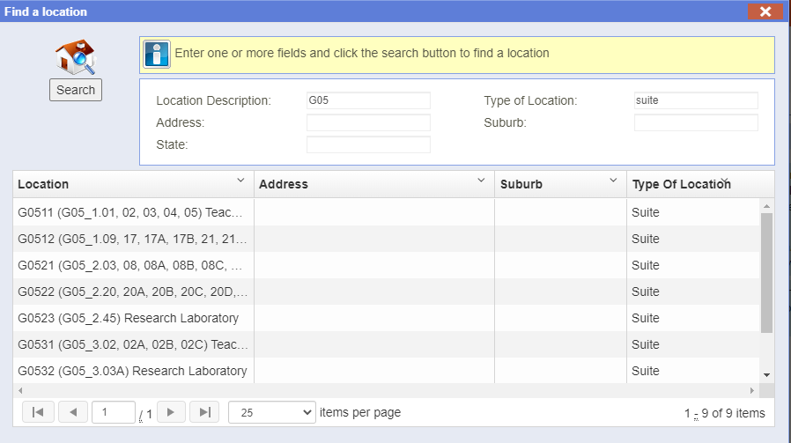
Locations & Facilities List all locations where any part of the activity described may take place including storage of materials. Click the ‘Display Locations’ button to load the locations. Certifications held are displayed along with expiry dates for each location e.g OGTR PC2, DAWE BC2. Search for a location by clicking the 🔍 button in the ‘Add a Location’ field and use the ‘Find a Location’ popup (Figure 7) to search and select the location. When searching enter the building code in the ‘Location Description’ field and ‘Suite’ in the ‘Type of Location’ field to return results for the suites only. Click the location from the results list to return to the locations tab and select the role from the ‘Select a Role’ dropdown menu then click ‘Add’ to finish adding the location. It is important to add the locations as suites as all the rooms associated with the certified facility will be added automatically. Where necessary individual rooms can be added if a suite is not available or permission to work in only one room of a large facility has been granted.
Figure 7 - Find a location tool.

People Add all persons the persons that will be permitted to work on the application following approval of the activity. Search for people by clicking the 🔍 button in the ‘Add Person’ field and use the ‘Find a Person’ popup to search and select the person. Click their name from the results list to return to the people tab and select their role from the ‘Select a Role’ dropdown menu then click ‘Add’ to finish adding the person. The person should be visible in the list and Certifications held displayed along with expiry dates for each person e.g. Annual Fire, General Biosafety. Each application should have a Project Leader assigned.
Risk Assessment This displays the GSafe risk assessments for the activity. A previously completed and approved risk assessment can be added by selecting the 🔍 button and searching for the Risk Assessment in the ‘Find a Risk Assessment’ window that will appear. You can start a new risk assessment by selecting the + button. This will open the GSafe risk assessment module in a new browser tab with a new application started and ready to complete.
Attachments The attachments tab stores information about procedures or materials to aid in assessment of the application by reviewers as part of the approvals process. Remember to add a reference to the information from other parts of your application such as Experimental Procedures if you expect reviewers to consider this information in their review of your application. It can also hold documents for project participants to reference or view such as an approval memo that is required to be read and understood prior to online declarations being made. Remember to click the ‘Save’ button before navigating away from the attachments tab or the attachment will not be uploaded.
If you have any questions regarding this process please contact the HS&W Biosafety team at safety@griffith.edu.au

