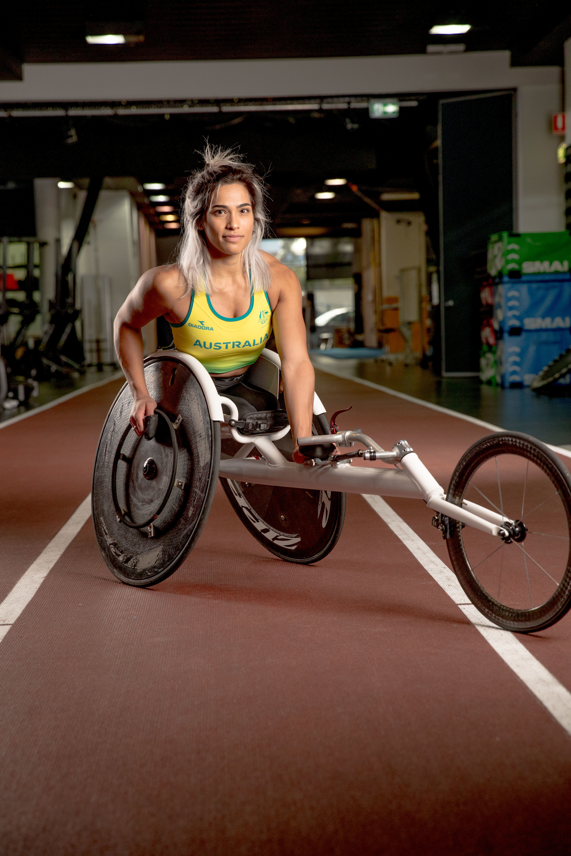

Disability Access and Inclusion Action Plan, 2024-2025

Contents
Disability Access and Inclusion Action Plan, 2024-2025 1
Acknowledgement 3
From the Vice Chancellor and the Deputy Vice Chancellor (Education) 3
Foreword 4
Our history and values 4
Principles underlying the Plan 4
Conventions, legislation and policy 5
Griffith's Strategic Commitments 6
United Nations Sustainable Development Goals (SDGs) 6
Governance and implementation 7
Monitoring progress on disability access and inclusion 7
Leadership 7
Key success measures 7
Disability Access and Inclusion Action Plan, 2024-2025 8
1. Unleash the potential of our people 9
2. Enhance accessibility and inclusion in Griffith's campus environments 10
3. Optimise Griffith’s learning and teaching experience and success for students with a disability. 11
4. Amplify opportunities to grow and promote Griffith’s research strengths related to disability. 13

Acknowledgement
Griffith University acknowledges the people who are the Traditional Custodians of the land and pays respect to the Elders, past and present, and extends that respect to all Aboriginal and Torres Strait Islander peoples.
We also acknowledge the lived experiences, diversity and intersectionality of people with disabilities, and as a values-based organisation are proud of the commitment of our staff, students and partners to equity, diversity and inclusion.

From the Vice Chancellor and the Deputy Vice Chancellor (Education)
Equity, diversity and inclusion have been part of Griffith University's values since its inception. We have a proud history of being at the forefront of disability inclusion and were the first Australian university to establish designated support services for students who are Deaf or hard of hearing.
Building on this history, we have invested in Griffith’s research beacon Inclusive Futures: Reimagining Disability. Inclusive Futures focusses on disability across the lifespan, taking a 'cell to community' approach to health and wellbeing. It unites efforts from all sectors and fields of research to reach new ways of reducing impairment, increasing participation and building better responses to disability.
As part of our preparations for this new Plan we worked with a panel of Griffith experts and representatives to carry out an assessment of Learning and Teaching (L&T) issues for students with disability. Staff and student stakeholders were interviewed as part of this project. 108 survey and written responses were considered, and a scan of national, state and Griffith data, legislation and policy was undertaken in the context of Griffith’s strategic aspirations. As a result, a set of recommendations was produced which has resulted in the Learning and Teaching Supports for Students with a Disability Implementation Plan and other actions within this Plan.
We also committed $20 million to identify and prioritise projects that address physical accessibility and inclusion of our existing building environment. These are progressing well and will continue to be implemented in the life of this Plan.
This Disability Access and Inclusion Action Plan, 2024-2025 demonstrates the practical and holistic way we will live our values and ensure we are Creating a brighter future for all.

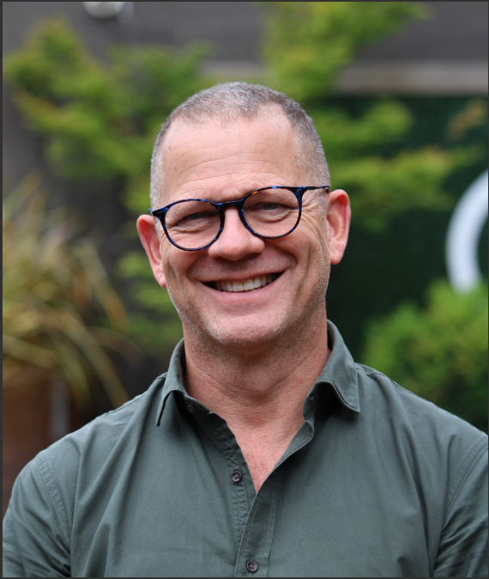
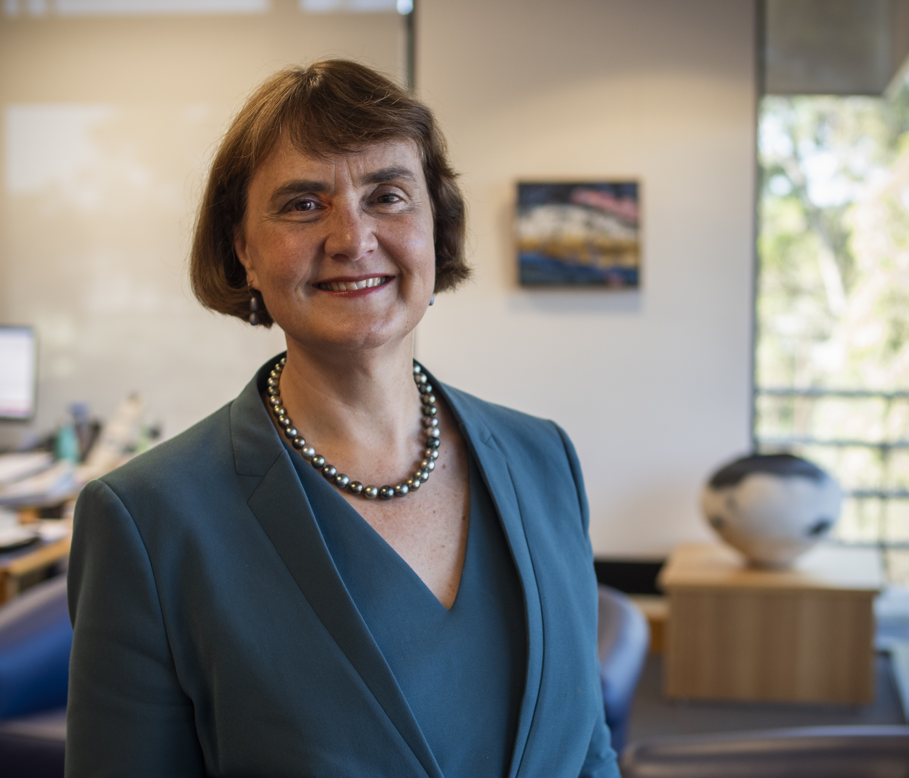
Professor Carolyn Evans Professor Shaun Ewen
Vice Chancellor and President Deputy Vice Chancellor (Education)

Foreword

Our history and values
Griffith’s fifth Disability Access and Inclusion Action Plan (DAIAP) builds on the achievements of earlier Plans, reflecting the University’s longstanding values and commitments. This Plan was developed in extensive consultation with Griffith students and staff with lived experience of disability and senior leaders. Griffith’s DAIAP promotes a holistic and systems approach to addressing the barriers that exclude people with disability from accessing, participating and succeeding fully in learning and work environments.

Principles underlying the Plan
The following principles will underpin the success of the Plan:
- Social model of disability: adopt an approach that reflects a contemporary, social model of disability rather than perpetuating a deficit model. Social models of disability recognise that disability is not a static condition inherent to the person, but results from the interaction of personal characteristics and attitudinal and environmental barriers (see Convention on the Rights of Persons with Disabilities, 2007)
- User centred design and ‘nothing about us without us’: commit, as an overarching principle and practice, to user centred design and a ‘nothing about us without us’ approach including consulting, co-designing and implementing to ensure an environment that is proactively inclusive and creates a sense of belonging for people with a disability
- Universal design: adopt, wherever possible, the principles of universal design and inclusive practice
- Intersectionality: recognise the diversity of intersecting identities and experiences of people with a disability
- Strengths-based approach: build on our current strengths, while also seeking to continuously improve the quality of the experience for people with disability
- Leadership: build and demonstrate inclusive leadership and promote Griffith's strategic diversity and inclusion aims
- Resourcing: ensure that the implementation of the Plan is supported by appropriate and sustainable levels of resourcing
- Planning and performance: embed the implementation of the Plan to the University’s planning cycle and senior leader performance
- Monitoring and reporting: develop regular review processes to evaluate the impact of the Plan and specific activities/initiatives and to inform further implementation activities.
- Recognition and reward: recognise and reward inclusive practice and celebrate progress on the implementation of the Plan.

Conventions, legislation and policy
Our disability access and inclusion efforts are also informed by international instruments such as the United Nations Convention on the Rights of Persons with Disabilities, The Universal Declaration of Human Rights the Marrakesh Treaty and Australian legislation and subordinate legislation such as the Disability Discrimination Act 1992 (Cth), Disability Standards for Education 2005 (Cth), Higher Education Standards Framework (Threshold Standards) 2021 made under section 58(1) of the Tertiary Education Quality and Standards Agency Act 2011 (Cth), Disability (Access to Premises-Buildings) Standards 2010 (Cth) and AS1428, Anti-Discrimination Act 1991 (Qld), Human Rights Act 2019 (Qld), Guide, Hearing and Assistance Dogs Act 2009, Fair Work Act 2009, Disability Services Act 2006 (Qld), and Workplace Health and Safety Act (2011). We operate in a system where the National Disability Insurance Scheme Act 2013 (Cth) impacts on the Griffith community. Our procurement practice is informed by the Queensland Procurement policy that aims to 'support disadvantaged Queenslanders – by increasing procurement with genuine, quality social enterprises.'

Our plan seeks to build on a number of recommendations outlined in the Final Report of the Royal Commission into Violence, Abuse, Neglect and Exploitation of People with Disabilities, Executive Summary - Our Vision for an Inclusive Australia and Recommendations.



Griffith's Strategic Commitments

This Disability Access and Inclusion Action Plan is being implemented as Griffith University's Strategic Plan (2020-2025) ends and our new 10 year strategy emerges. What remains consistent is that at Griffith we pursue our vision through our core principles of excellence, ethics and engagement and we continue to hold progress on equity, diversity and inclusion at our core.

United Nations Sustainable Development Goals (SDGs)
The Griffith University Strategic Plan (2020-2025) commits to using the United Nations Sustainable Development Goals (SDGs) as a framework for articulating and measuring our impact with respect to social justice. The 'Leave no one behind' principle is central to its Sustainable Development Goals (SDGs). Disability access and inclusion is embedded in a number of SDGs (Figure 1) and they will help guide some of our focus in a number of priority areas within the Plan.

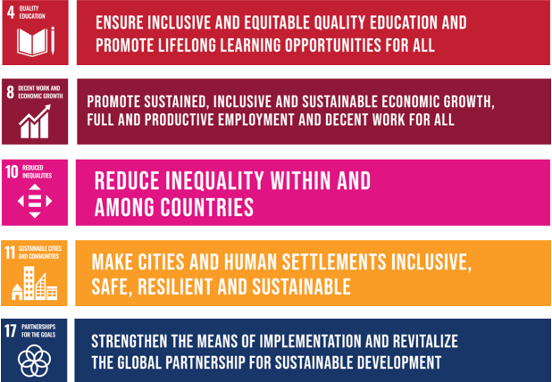

Figure 1: Key Sustainable Development Goals related to disability access and inclusion.

Governance and implementation

Monitoring progress on disability access and inclusion
Progress on the Plan will be reported to the Vice Chancellor and Executive Group via the Equity, Diversity and Inclusion Committee.
The Equity, Diversity and Inclusion Committee will monitor available data and provide insights on trends.
The Disability Advisory Committee will monitor the implementation of the Disability Access and Inclusion Action Plan and provide updates to the Griffith Equity, Diversity and Inclusion Committee as required.
Each year we commit to examining the employee engagement survey to identify any differences between staff who identify as having a disability and those who do not.
The Disability Advisory Committee’s constitution and membership will be reviewed during the life of this plan to ensure the greatest impact for both consultation and implementation.

Leadership
The Deputy Vice Chancellor (Education) leads Griffith's strategic approach to disability access and inclusion and provides oversight of the Disability Advisory Committee, Equity, Diversity and Inclusion Committee and the Disability Access and Inclusion Action Plan.
The Leadership Capability Framework and Success Profiles outline the expected behaviours and capabilities that will support the implementation of the Plan and continue building an inclusive University environment.
The University commits to the actions within the Plan being embedded in the appropriate Group or Major Organisational Area Plans and performance documents.

Key success measures
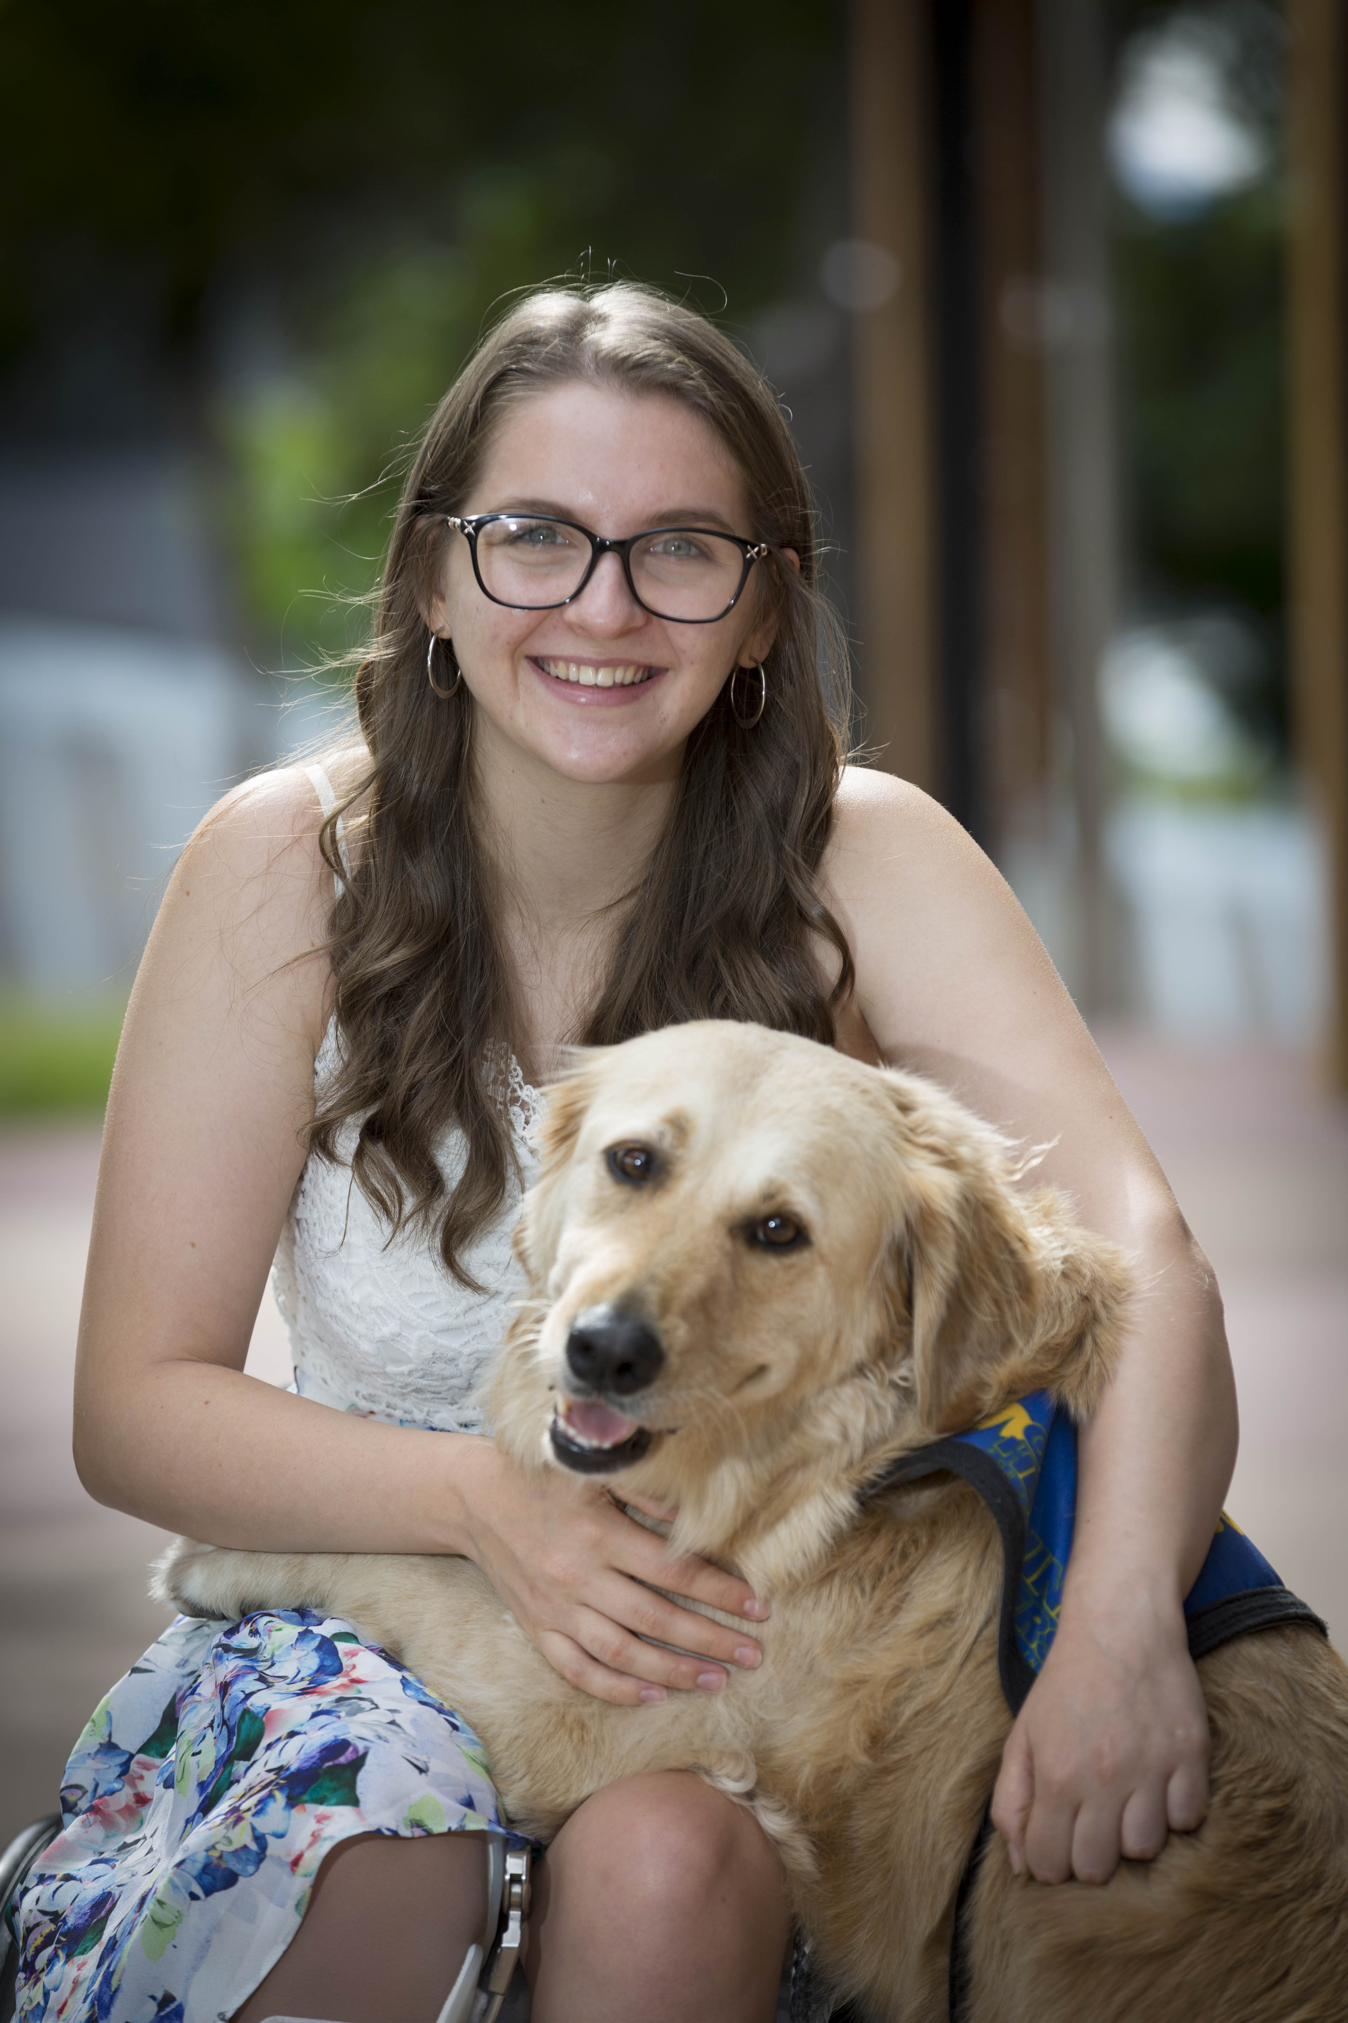
The key success measures for this Plan include:

 | Closing the gap on staff engagement between employees who do and do not have a disability.
 | Improving the accessibility of Griffith's environments.
 | Improving access, retention and employability of students with disability.


Alumni Erin Mills, Speech Pathologist and Speech Therapy Team Lead.

Disability Access and Inclusion Action Plan, 2024-2025
Actions within the Disability Access and Inclusion Plan, 2024-2025 relate to four goals:

 | People: unleash the potential of our people
 | Supportive environments: enhance accessibility and inclusion in our built and social environments
 | Learning and Teaching: optimise our learning and teaching experience and success
 | Research: grow and promote our research strengths

These themes are supported by the important enablers of:

 | Digital environments: continuing to enable accessibility and inclusion in our digital environments (e.g. Digital Masterplan, Digital Audits, procurement decision-making for digital solutions, compliance with Web-content Accessible Guidelines, staff training and engaging with feedback on digital accessibility)
 | Strategic partnerships: growing our external engagement and strategic partnerships (in particular with those organisations with public disability action plans, and who are employers of choice for people with disabilities)
 | Effective Processes: embedding disability access and inclusion opportunities in Griffith's business processes (e.g. policy and procedures, procurement processes, and use of social impact assessments, and monitoring and reporting on progress in the Plan)

1. Unleash the potential of our people
Action | Accountable and Responsible Officers
1.1 Inclusive Talent Acquisition and Onboarding  Continue to build disability inclusion resources and learning and development opportunities for HR Talent Acquisition, HR Business Partnering and University hiring managers.  Add information for people with disabilities to onboarding sites including information on the new Griffith Staff with Disability Network. | Responsible: Senior Lead (Inclusion & Development)  Accountable: Director HR
1.2 Staff diversity data  Improve 'My Staff Equity' data categories and consultation opportunities related to disability. | Responsible: Senior Lead (Inclusion & Development), Product Manager - Finance & HR  Accountable: Chief Digital Officer
1.3 Procedure and toolkits  Create staff resources that provide information on disability inclusion and workplace adjustments including staff disability access and inclusion procedure and toolkits for HR Employees and Managers. | Responsible: Senior Diversity & Inclusion Partner, Injury Management & Wellbeing Partners  Accountable: Senior Lead (Inclusion & Development)
1.4 Capability and Development  Further build, via learning and development opportunities (including the Senior Leadership Development Program), capability to promote a culture of inclusion and belonging for staff and students with a disability. | Responsible: Senior Lead (Inclusion and Development)  Accountable: Head, Capability and Development
1.5 Staff with Disability Network  Establish a dedicated network for staff with a disability. | Responsible: Diversity & Inclusion Partner  Accountable: Senior Lead (Inclusion & Development)

2. Enhance accessibility and inclusion in Griffith's campus environments
Action | Accountable and Responsible Officers
2.1 Griffith’s Masterplans  Ensure that disability access and inclusion is maximised in Griffith’s Masterplans for all campuses by ensuring early consultation with people of lived experience of disability and prioritising universal design. | Responsible: Director, Major Projects & Planning  Accountable: Director, Major Projects & Planning
2.2 Accessibility and inclusion of our existing building environment  Deliver on a major strategically funded capital improvement project that identifies and prioritises projects that address physical accessibility and inclusion of our existing building environment. Utilise Griffith University Design Guidelines and Design Review Process to ensure accessibility. | Responsible: Associate Director, Minor Projects  Accountable: Director Campus Life
2.3 Scoping Griffith One App - Digital Wayfinding  Devise a workplan and associated budget and options for accessible digital wayfinding within the Griffith One student App. | Responsible: IT Director, Learning & Teaching  Accountable: Chief Digital Officer, DVCE
2.4 Inclusive Events and Communication  Develop and communicate guidelines to assist Griffith staff organise and deliver accessible and inclusive events. | Responsible & Accountable: VP Advancement


Matt Levy OAM is an Australian Gold Medal winning Paralympian swimmer, motivational speaker, and disability advocate and in partnership with Griffith University has established the Matt Levy Inclusive Futures Scholarship.

3. Optimise Griffith’s learning and teaching experience and success for students with a disability.
Action | Accountable and Responsible Officers
3.1 Institutional capability  Have an institutional-wide focus to support students who experience disability, with the objective to raise institutional capability to attract, retain and support students with disability.  - Make a case to add student disability metrics as a KPI for relevant leaders  - Annually agree and embed appropriate actions to manage, and processes to monitor, achievement to KPI targets. | Responsible: Registrar, Student Life  Accountable: DVCE
3.2 Disability support services  Refocus disability support services to a tier-based service, with the objective to create a disability service structure where the service’s level of engagement is defined by the complexity of students’ needs.  The Student Disability and Accessibility Services has the capacity to delivery high quality case management for students with complex disabilities by embedding routine service provision directly at point of access  - Disability Advisory Committee to agree to a new question set within the Student Experience Survey and the expected outcome measures for staff and students’ awareness of, engagement with, and user satisfaction with disability services  - Student Life Business Transformation team to explore ways of removing transactional workloads from the Student Disability and Accessibility Services to allow them to focus on complex case management. This work will explore the use of standard templates and advice sheets for academics as well as the design new process flows for academic adjustments.  - Digital Solutions to work with the outcomes of the above to design and implement automations so it is faster and easier for staff and students to request / deliver reasonable adjustments. | Responsible: Registrar, Student Life  Accountable: DVCE
3.3 Student Experience  Develop an Access to Learning strategy for students who experience disability with the objective to embed in current policy, procedures and processes reflective practices that enhance the student experience for those that experience a disability as measured by the new questions within the Student Experience Survey.  The Learning and Teaching Committee (LTC) will keep itself informed of appropriate research led practices and drive enhancement opportunities to support students who experience a disability. Their specific focus will include:  - Staff development to increase awareness of legislative requirements and appropriate support for those who experience a disability  - Creating accessible curriculum and assessment designs and how this can be best supported by the physical and digital environment  - Strategies to alleviate accessibility issues within WIL and fieldwork  The work of LTC will be closely aligned to the University’s mental health strategy. | Responsible: L&T Committee  Accountable: DVCE and Chair L&T Committee
3.4 Learning and Teaching Supports for Students with a Disability Implementation Plan  Activate the Learning and Teaching Supports for Students with a Disability Implementation Plan in response to the report and recommendations on learning and teaching issues for students with a disability. | Responsible: Office of the DVCE  Accountable: DVCE
3.5 Global Mobility Experiences (GME) and Exchange Opportunities  Leverage virtual Global Mobility Experiences (GME) to increase GME participation for students with a disability. Increase the awareness and promotion of virtual GME experiences to students with a disability.  Explore targeted exchange opportunities with accessible universities for students with a disability. | Responsible: Director, Griffith International  Accountable: VP Global

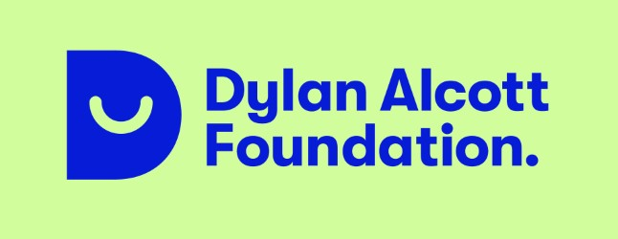
The Dylan Alcott Foundation Scholarships support students with disability who are studying an undergraduate degree at Griffith University. The Dylan Alcott Foundation is committed to helping young Australians with disability overcome the barriers of entry to sport and education by providing fundraising for grants, scholarships and mentoring.

4. Amplify opportunities to grow and promote Griffith’s research strengths related to disability.
Action | Accountable and Responsible Officers
4.1 GU Disability Scholars Research Scholarship  Scope, establish and then monitor the effectiveness of the GU Disability Scholars Research Scholarship (a recognised pathway to support scholars who have a disability and are seeking to enrol in a PhD) and make adjustments as needed. | Responsible and Accountable: Dean GGRS
4.2 External investment opportunities  Explore external investment opportunities for PhD scholarships and Post-Doctoral Fellowships for research related to disability access and inclusion and rehabilitation and scholars with disability. | Responsible: DVCR, VP Industry & External Engagement, VP Advancement.  Accountable: DVCR
4.3 Maximise research impact  Maximise research impact of large-scale research projects in disability and rehabilitation (e.g., Inclusive Futures Beacon) and maintain reputation as nationally leading research institution for disability and rehabilitation. | Responsible Officer: Director Inclusive Futures: Reimagining Disability  Accountability: DVCR

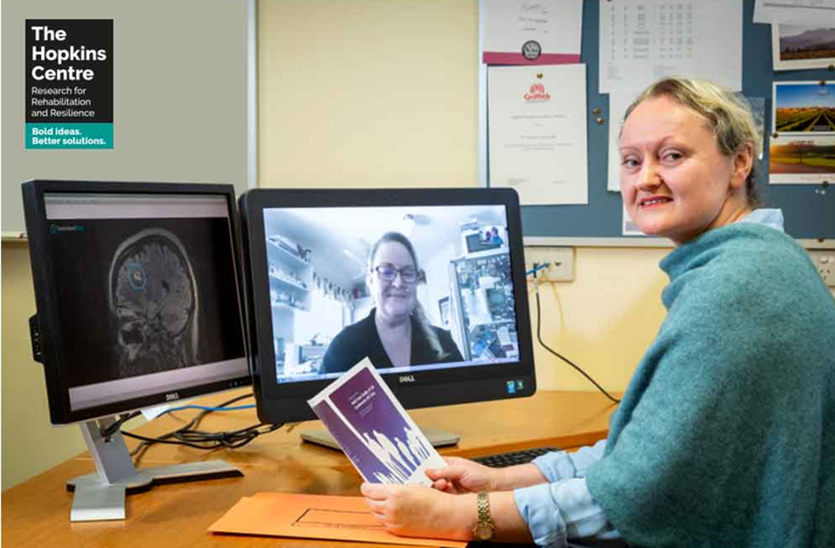
Professor Tamara Ownsworth, clinical neuropsychologist at The Hopkins Centre (Research Director, Research Development) and the School of Applied Psychology at Griffith University talking with Julia Robertson brain cancer survivor, PhD candidate, researcher and disability advocate.

The UN Convention on the Rights of Persons with Disabilities definition of universal design is, 'the design of products, environments, programmes and services to be usable by all people, to the greatest extent possible, without the need for adaptation or specialised design'. The Center for Inclusive Design and Environmental Access defines universal design as 'a process that enables and empowers a diverse population by improving human performance, health and wellness, and social participation.' (Universal Design Position Statement, Centre for Universal Design Australia).

