EDUCATION RESOURCE  SECONDARY SCHOOL | 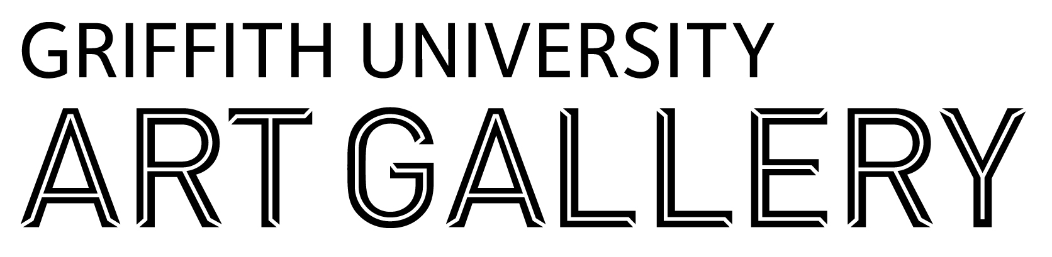
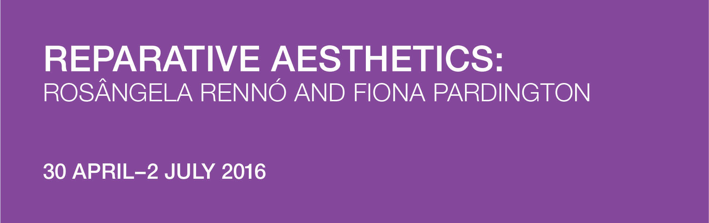

INTRODUCTION TO THE EXHIBITION
How do artists confront troubling national histories? ‘Reparative Aesthetics’ brings together the work of two photographers from the southern hemisphere, Rosângela Rennó (Brazil) and Fiona Pardington (New Zealand), to consider their distinct approach to the ‘archival turn’ – a trend in contemporary art that seeks to recover forgotten or neglected histories. Against the dominant trends in political art, Rennó and Pardington have adopted a reparative approach to shameful events of the past. Their work seeks to offset this shame by drawing attention to the power and beauty of the original archival objects and images. Thus, rather than focusing solely on wrong-doing, their work combines both positive and negative feelings.

In the series ‘Vulgo [Alias]’ 1998-99, Rennó makes portraits from found identification photographs of the backs of heads of prisoners at the São Paulo State Penitentiary Museum taken between 1920-40. Rennó transformed the original identification images into large format photographs where delicate rose discolouration directs the eye towards the cowlick patterns of scalp and hair. The men’s individuality is underscored by her quirky titles based on their hair patterns. Pardington also uses large format photographs in the 2009-10 series ‘Āhua: A Beautiful Hesitation.’ She presents nineteenth-century life casts made by French phrenologist Pierre-Marie Alexandre Dumoutier on one of the last so-called voyages of discovery led by French explorer Dumont d’Urville from 1837-40. The casts, originally intended to support emerging theories of racial difference, placed the Pacific peoples into a racial hierarchy. 170 years later, Pardington transforms the casts into startlingly beautiful images of distinct individuals.

The works of these two artists encourage a reassessment of the treatment of vulnerable subjects – their objectification in the interests of science and/or security – while also holding together in exquisite tension the past and present, damage and repair.

INTRODUCTION TO THE ARTISTS
Rosângela Rennó was born in 1962 in Belo Horizonte, Brazil and lives and works in Rio de Janeiro. Rennó graduated from architecture from the Federal University of Minas Gerais, Belo Horizonte in 1986, and from visual arts from the Escola Guignardi, Belo Horizonte in 1987. In 1997 she received an Arts Doctorate from the School of Communications and Arts of the University of São Paulo. Rennó has exhibited extensively internationally.

Rennó calls the sources of her works ‘dead files’ – newspapers, old family albums, slides found in flea markets, archives and other sources. She is interested in how anonymous and overlooked subjects in non-art photography can express far more about the human condition than photographs with an artistic intent. Rennó’s work salvages stories of ordinary lives and transforms archival photographic material into larger compositions, often in the form of installations or photographic books. She is interested in the imperfection of both memory and photography.

Fiona Pardington was born 1961 in Devonport, Auckland and is of Scottish (Clan Cameron of Erracht) and Māori (Kāi Tahu, Kāti Mamoe, Ngāti Kahungunu) descent. Pardington received a Bachelor of Fine Arts from the Elam School of Fine Arts in 1984. In 2003 she was awarded a Master of Fine Arts in Photography followed in 2013 by a Doctorate in Fine Arts from The University of Auckland and was presented with the Ordre des Arts et des Lettres from the French government in 2016. Pardington has exhibited widely internationally.

Pardington’s early work is characterised by explorations in photographic technique, and in the late 1980s she was amongst a group of women artists who challenged a dominant social documentary aesthetic. She went on to focus on transforming the traditional genre of still-life, recording Museum taonga (Māori ancestral treasures) and other historic objects such as hei tiki (greenstone pendants) and the now extinct huia bird. Her investigation of museum collections breathes new life into hei tiki, natural-history specimens, life casts made on European voyages of discovery, death casts of French criminals and assassins, and much more. Pardington’s themes encompass the spirituality that underpins Māori customs and the metaphysical world and often also extend to sexual and cultural politics.

YEARS 7-8 FOCUS

Observe - First impressions – what can you see?
Explore - What particular things do you notice or discover when you spend more time looking?
Investigate - Do you think the artist has made some things stand out?
Evaluate (Meaning) - Are ‘standout’ things clues to find out what the artist is saying?
Evaluate (Relevance) - Does anything about this work interest you in any way. Can you relate it to anything that you know and are familiar with?

After looking at all the artworks, choose two to analyse further. Record the names of the works at the top of the table. Make observations in the table below.

Artwork 1: |  | Artwork 2:
What is the subject matter of these artworks? (e.g.: is it the body; popular culture; science; history?)

Analyse and reflect: How are Rosângelo Rennó’s artworks different from Fiona Pardington’s artworks?

What are the dominant visual conventions of the work?

Design Elements: line, colour, texture, shape and form
Design Principles: unity, balance, scale, proportion, emphasis and contrast

What techniques have the artists used? What materials have been used to make the artworks?

Consider the titles of the artworks and explain do they relate to the subject matter?

How are these portraits different to the portraits that you take every day? (eg. selfies?)

CREDITS
Guest curator: Professor Susan Best, Convenor, Fine Art and Art Theory, Griffith University
This resource has been developed by Griffith University Art Gallery in partnership with Griffith University 4th Year Bachelor of Secondary Education (Visual Arts) students: Hannah Banister, Juliet Bucknell, Lauren Coyle, Laura Dean, Stephanie Dixon, Claire Fountain, Inneke Hay, Elizabeth Hendrie, and Ethan Lam; led by Dr Marta Kawka, Lecturer, School of Education and Professional Studies.

YEARS 9 - 10 FOCUS

Observe- First impressions – what can you see?
Explore- What particular things do you notice or discover when you spend more time looking?
Investigate- Do you think the artist has made some things stand out?
Evaluate (Meaning)- Are ‘standout’ things clues to find out what the artist is saying?
Evaluate (Relevance)- Does anything about this work interest you in any way. Can you relate it to anything that you know and are familiar with?
Choose one artwork by Fiona Pardington and one artwork by Rosângela Rennó. List the differences and similarities between the two artworks.

Artwork 1: |  | Artwork 2:
Why do you think that an artist would photograph an object in a museum or archive and present it as an artwork?
How would the meaning differ if the original object or subject were present?

Fiona Pardington discovered these life casts in the process of researching her own ancestral history. How might this affect/change the meaning of the artworks?

Consider the following quote by Rosângela Rennó and interpret what you think the artist trying to say and justify why?

“I was looking at thousands of portraits that were testimonies to nothing, twice forgotten faces with numbers and without names.”

CREDITS
Guest curator: Professor Susan Best, Convenor, Fine Art and Art Theory, Griffith University
This resource has been developed by Griffith University Art Gallery in partnership with Griffith University 4th Year Bachelor of Secondary Education (Visual Arts) students: Hannah Banister, Juliet Bucknell, Lauren Coyle, Laura Dean, Stephanie Dixon, Claire Fountain, Inneke Hay, Elizabeth Hendrie, and Ethan Lam; led by Dr Marta Kawka, Lecturer, School of Education and Professional Studies.

YEARS 11-12 FOCUS

Ancestral portraits allow forebears to come in presence, cancelling the distance between life
and death, subject and object. They act as portals between te pō (the dark world of ancestors) and te ao (the everyday world of light).
ANNE SALMOND in Fiona Pardington: The Pressure of Sunlight Falling, 2011, p.135.

I was looking at thousands of portraits that were testimonies to nothing, twice forgotten faces with numbers and without names.
ROSÂNGELA RENNÓ in Rosângela Rennó, Vulgo [Alias], ed. Melissa Chiu, 1999, p.44
CONTEXTS - philosophical and ideological, theoretical, institutional, psychological, scientific
TERMINOLOGY -
phrenology  (noun) The detailed study of the shape and size of the cranium as a supposed indication of character and mental abilities. (origin) Early 19th century: from Greek phrēn, phren- 'mind' + -logy.  [See further information at http://www.oxforddictionaries.com/definition/english/phrenology] | āhua  1. (verb) (-tia) to form, make. 2. (noun) shape, appearance, condition, character, likeness, nature, figure, form.  [ See further information at http://maoridictionary.co.nz/word/87]
Are the subjects in these photographs being objectified? What can we learn (if anything) about their individual identities from these images?
Are these artworks political or apolitical? Why? What key ideas do you think the artists are trying to convey?
Fiona Pardington learnt about her cultural identity later in life as she researched her ancestry. What do you think is the significance of these faces to her? What drove her to photograph these late 1830’s phrenology studies?
Consider the above quote by Rosângela Rennó and interpret what you think the artist trying to say and justify why?
Choose one artwork to analyse in detail. Describe the form and content of the piece. How does the aesthetic relate to the concept?
Consider the format of the exhibition and the gallery space. How does the method of display affect the reception of the artwork?
Why photograph and re-contextualise objects/images that exist elsewhere?

CREDITS
Guest curator: Professor Susan Best, Convenor, Fine Art and Art Theory, Griffith University
This resource has been developed by Griffith University Art Gallery in partnership with Griffith University 4th Year Bachelor of Secondary Education (Visual Arts) students: Hannah Banister, Juliet Bucknell, Lauren Coyle, Laura Dean, Stephanie Dixon, Claire Fountain, Inneke Hay, Elizabeth Hendrie, and Ethan Lam; led by Dr Marta Kawka, Lecturer, School of Education and Professional Studies.

