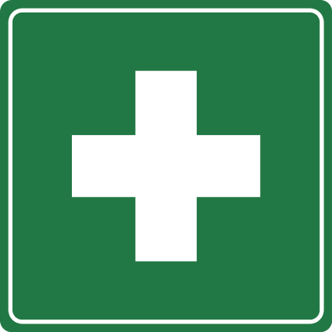

First Aid Officer
Your local First Aid Officer is:

Visit or call me if you require first aid assistance.
My building and room number is: .
My telephone extension is: .

IN AN EMERGENCY
- Fire/Ambulance/Police (on internal phone) Dial 0 first, then 000.
- Fire/Ambulance/Police (on public/mobile phone) Dial 000 or 112.
- Notify Security (on internal phone) Dial 7777.
- Notify Security (on public/mobile phone) Free call 1800 800 707.
- Notify Security (red phone) – located in lifts Lift hand-set to ear.

